AI ASSISTED CODING ASSIGNMENT-10.4

TASK-1: AI-Assisted Code Review (Basic Errors)
Write python program as shown below.
Use an AI assistant to review and suggest corrections

NAME:MD NASRIN
BATCH:19
2503A51L23

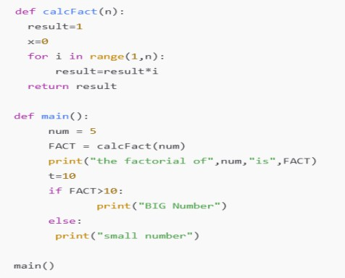

PROMPT:
Review the above code and suggest corrections. rewrite the correct code with comments.
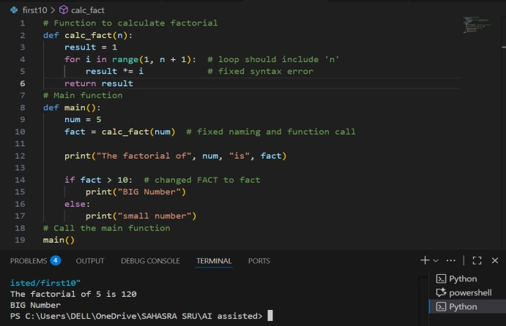

TASK-2 :Automatic Inline Comments

Write the Python code for Fibonacci as shown below and execute.

USE AI to improve variable names, add comments, and apply PEP8 formatting (cleaned up).
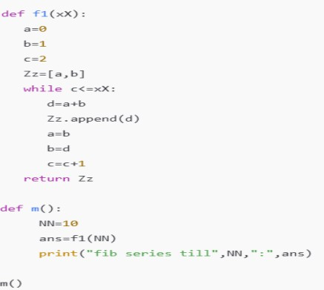

PROMPT:
USE AI to improve variable names, add comments, and apply PEP8 formatting (cleaned up) for the above python code.
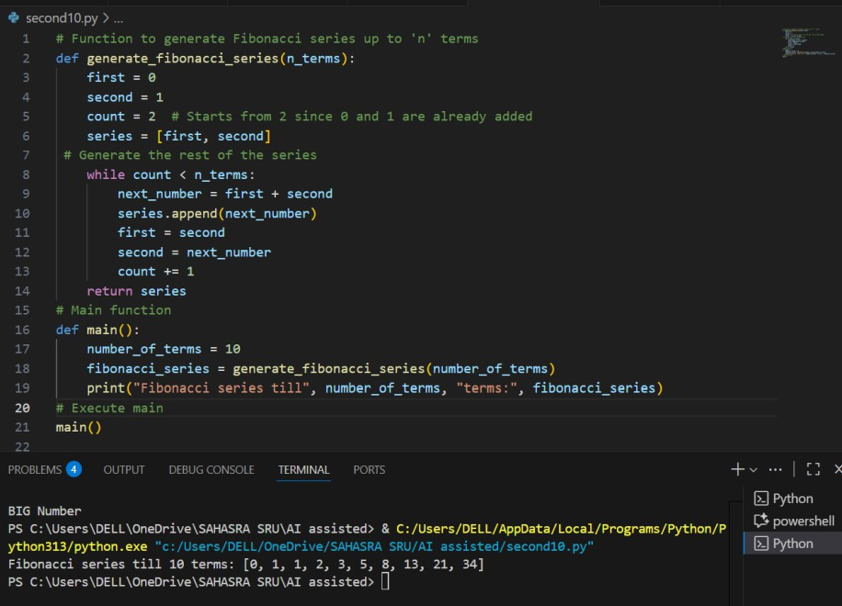
Task Description#3
Write a Python script with 3–4 functions (e.g., calculator: add, subtract, multiply, divide). Incorporate manual docstring in code with NumPy Style
PROMPT:

Use AI assistance to generate a module-level docstring + individual function docstrings. Compare the AI-generated docstring with your manually written one.

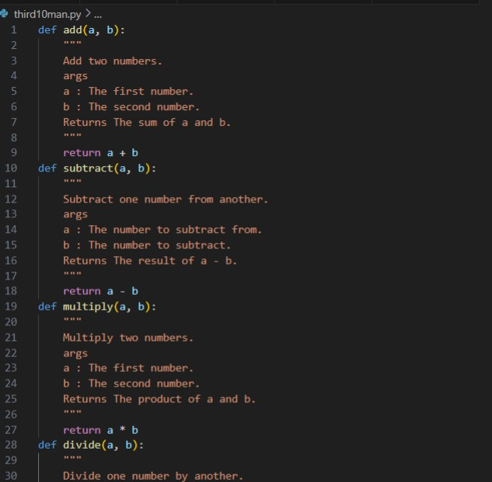
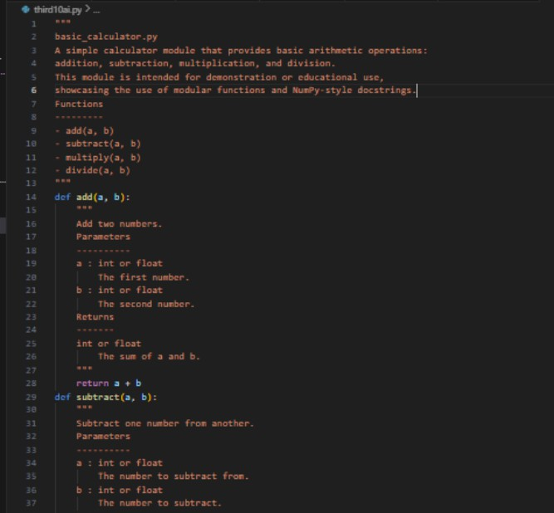

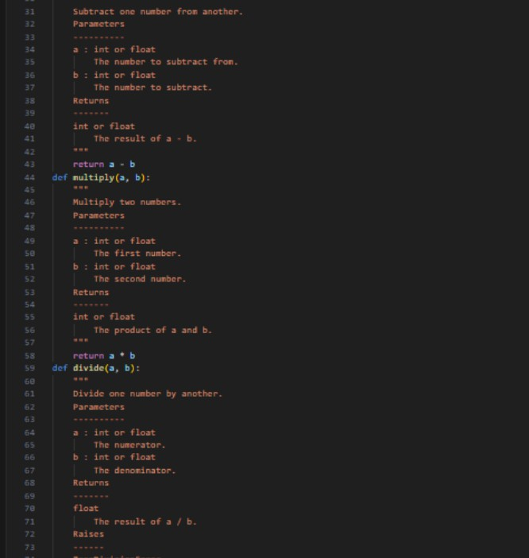

OBSERVATION:
AI-assisted docstrings offer:
Professional structure Better readability
Tool compatibility
Reusability in teams, APIs, and documentation websites

